Proposed Adaptive e-Learning Model as a Solution for Current e-Learning Challenges
Abstract
e-Learning solutions face challenges that is leading a group of researchers to doubt the efficiency and effectiveness of such an experience. Challenges include lack of adaptivity in the e-Learning process. Though adaptive and intelligent features in information systems and e-Learning are many, they have not been utilized in the most efficient manner yet due to many reasons, mainly architectural. Service Oriented Architecture (SOA) as a design pattern that presents systems as collection of reusable services that can be exposed and consumed on the Internet with standard interfaces has many advantages that can be achieved on technical, managerial, and implementation aspects of the system. SOA can be useful in integrating long decades and efforts of adaptive and intelligent features of e-Learning in today’s e-Learning systems. This paper addresses some of the challenges facing today’s e-Learning process by presenting the survey results of a case study of fourth year students at Faculty of Computers and Information Sciences in Mansoura city University, Egypt. Proposed Adaptive Learning Model is presented as a suggested solution to the highlighted problems that came clear after the evaluation. Finally, a Learning Objects (LOs) Recommender as a Service that is important to support the proposed Adaptive Learning Model is presented. LOs Recommender as a Service utilizes LOs Meta-Data and Student Preferences based on Students’ Navigation Model between different LOs. Today’s e-Learning information systems’ architects can make use of SOA in integrating major e-Learning components together, side by side with adaptive and intelligent features to provide students with required personalized learning environment.
Keywords: e-Learning, Adaptive e-Learning, Service Oriented Architecture (SOA), Information Systems’ Integration, Recommender as a Service, SCORM Learning Objects
- Introduction
E-Learning can be thought of as the learning process created by interaction with digitally delivered content, services, and support. E-Learning involves intensive usage of Information and Communication Technology (ICT) to serve, facilitate, and revolutionize learning process (Zongmin Ma 2006, William Horton 2003, Michel Graham Moore 2003). Learning paradigms/methodologies include traditional learning “face-to-face”, distance learning “complete asynchronous time and place learning delivery; mainly online”, and blended learning “learning that combines instruction lead learning with online learning activities leading to reduced classroom contact hours”. Blended learning has the potential to increase student learning while lowering attend rates compared to equivalent fully online courses (Charlez D. Dziuban et al. 2004). Blended learning is the learning paradigm that attempts to optimize both traditional learning and distance learning advantages, potentials, and benefits while eliminating both learning paradigms shortages and challenges. When compared to traditional learning paradigm, blended learning is found to be consistent with the values of traditional learning paradigm adopted in almost all higher education learning institutions for decades, and has the proven potential to enhance both the effectiveness and efficiency of meaningful learning experiences (D. Randy Garrison and Heather Kanuka 2004). Learning Management System (LMS) is the software that automates the administration of education. LMS registers students, tracks courses in a catalogue, records data from learners, and provides reports to management. LMS is typically designed to handle courses by multiple publishers and providers. It usually doesn’t include its own authoring capabilities; instead it focuses on managing courses created by a variety of other learning resources. Sandy Britain and Oleg Liber present a prototypical LMS (Sandy Britain and Oleg Liber 1999). LMS was meant to support different learning models.
This paper goes as follows: Section Two presents the survey results of the selected group of faculty students highlighting the Problem Definition. Section Three presents the Proposed Solution; that is the Adaptive Learning Model. Section Four presents Proposed Solution IT Architecture. Section Six presents SOA Utilization in the proposed model. Section Seven presents detailed description for Learning Objects (LOs) Recommender as a Service and Section Eight Concludes the paper.
- Problem Definition
Current Blended Learning Model Paradigm faces many challenges; mainly pedagogical. Though today’s technologies advance by decades technologies used in teaching and education less than decade ago, a number of recent articles have commented that science education is no better today than it was fifty years ago. The National Assessment of Education Progress (NAEP) shows that in most areas today’s students are achieving at about the same levels as students tested in 1971 (Alfred Bork et al. 2008). E-Learning researchers know very well that this problem is not caused by technology; because as mentioned before technology has advanced greatly. This pedagogical issue is the result of:
- The attempt to use whatever technology currently available or becomes available in the near future without pedagogically considering student or the learning process.
- Allowing technology to stand against the learning process, because no matter what advancement we have achieved, technology is still limiting our dreams, and this situation takes place with e-Learning nowadays.
- The poor evaluation that is available for many of the innovations. Most of the required evaluations are either inadequate or doesn’t exist at all.
Alfred Bork et al. argue that some of the reasons why technology has not led to improvements in learning globally are:
- Grabbing Onto Each New Technology: The belief that each new technology will enhance learning needs more arguments about efficiency than just belief.
- Failure to Continue Successful Development: funders often prefer to look for something new rather than follow up on successful approaches because they want to make a mark by being in the forefront. Funders want to make a statement, and following up on someone else’s work doesn’t provide them with the credit or “name” they desire.
Pedagogically, most training methods and technologies produce, at best, “trained novices”. That is, they introduce facts and concepts to students, present them with relatively simple questions to test this new knowledge, and provide them with a few opportunities to practice using this knowledge in exercise or scenarios. However, becoming proficient requires extensive practice solving realistically complex problems in wide range situations, combined with coaching and feedback from managers, more experienced peers, or other types of experts (Jamed Ong and Sowmya Ramachandram 2003).
Most evaluations of today’s presented technologies in the learning model focus on technology aspects of the solution while ignoring the pedagogical aspect; almost at all. The result of using technology, particularly computers, in learning has so far not been impressive. A variety of studies and opinions have questioned the use of technology to improve learning. Although it has been many years since computers have begun to be used in learning environments, there is little improvement in learning, with or without technology. Although the use of technology in learning shows no significant difference, that is, computer learning is no better than traditional instruction, learners have been provided with the convenience of any time, any place learning. Students’ understand and retention improves when students learn by experience. Technologies such as collaboration, interactivity, modelling, simulations, virtual reality interfaces, and gaming will help students experience the skill being taught, but they have not helped students that far yet (Alfred Bork et al. 2008). Besides, students lack of awareness of different e-Learning technologies stand up against the presentation of effective e-Learning model.
Late in year 2008, authors conducted a pilot study for fourth year Information Systems department students at Faculty of Computers and Information Sciences of Mansoura city University, Egypt. Figure 1 presents the gender distribution of participating students. Though 57 students who conducted the questionnaire answered that they heard about e-Learning, and they all believe it is effective, authors found out that almost 25% of participating students don’t use internet as their main source of information as depicted in figure 2, which is weird when compared to the 100% e-Learning efficiency commit. What are the odds of using e-Learning not based on the internet? And what are the odds of finding an updated source of information that competes with the internet? Figure 3 shows that almost 85% of students classified themselves as good internet users, while 72% of them as depicted in figure 4 don’t even know what “tutorials” are, and of course e-Learning researchers know that web based tutorials is one of the main sources for teaching students. Though 85% of participants believe they can learn via e-Learning as shown in figure 5, and almost the same percentage agree to participate in an e-Learning as depicted in figure 6, only 68% of students appeared to be accepting the idea of using mobile in learning purposes as shown in figure 7. Though e-Learning researchers have been thinking about different methods to use mobile in the learning process, this pilot study shows that only 28% of students access the internet via their mobile phones as presented in figure 8, and only 46% of students are willing to participate in a free of charge mobile learning experience when asked to as clarified in figure 9. If learning via mobile is a challenging experience to the researchers due to mobile limited resources, mobile assessment has been recognized as one of the mobile learning activities that can be achieved effectively (A. M. Riad and H. A. El-Ghareeb (a), 2008). Figure 10 shows that 61% of the students said they will not participate in a mobile assessment experience when they are asked to. Figure 11 shows that 58% of the students believe M-Learning will not become popular. Finally, all students participated in the pilot study agreed that authors’ faculty utilizes different forms of e-Learning. Though authors’ faculty doesn’t provide an official site for e-Learning or any online courses, or assessment site, or any other form of e-Learning other than authors’ attempts, students still believe that e-Learning is efficient though they have not experienced it at all. We believe this means that most e-Learning researchers around speak more than they work, and claim more than they justify. Students believe that
e-Learning is effective without trying it, and are not excited about M-Learning no matter what research e-Learning researchers provide.

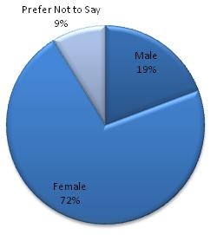  Figure 1: Gender Distribution | 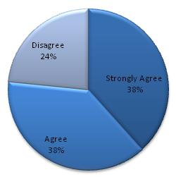  Figure 2: Internet is Main Source of Information
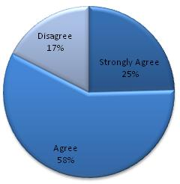  Figure 3: Good Internet User | 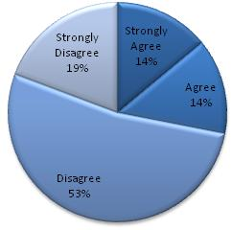  Figure 4: Familiar with Tutorials
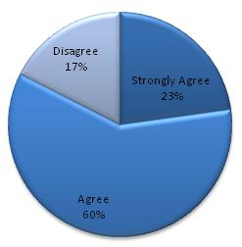  Figure 5: Students Can Learn via e-Learning | 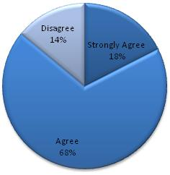  Figure 6: Participate in e-Learning
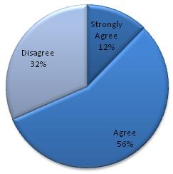  Figure 7: Use Mobile Learning | 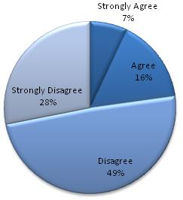  Figure 8: Access Internet via Mobile Phones
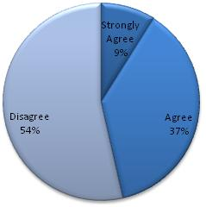  Figure 9: Participate in M-Learning Experience | 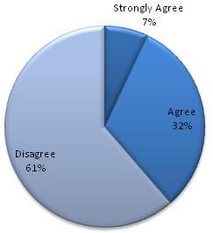  Figure 10: Participate in M-Assessment Experience
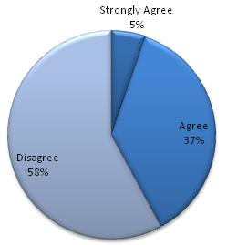
Figure 11: M-Learning will Become Popular
- Proposed Solution
Adaptive learning for students with many different backgrounds, learning styles, and interest is almost a must. Educational psychologists largely agree that students differ greatly in the ways they learn and very few teachers or professors can adapt learning to each student in the typical large classes, the costs associated with delivering different instruction for varied learning styles is prohibitive (Alfred Bork et al. 2008). In his experiments the most successful learning strategy was tutoring. Adaptive e-Learning that is supported with intelligent techniques and methods is one of the ways to support personalized e-Learning, and so authors believe that it will be the way to solve many of the limitations and today’s e-Learning challenges. Authors reviewed the different adaptive and intelligent e-Learning systems proposed over a long e-Learning research era, highlighting the maturity of adaptive and intelligent features and the e-Learning researchers attempt to introduce services based e-Learning systems in order to overcome many of the e-Learning challenges, like reusability, scalability, integration, and interoperability (A. M. Riad et al. (a) 2009). Authors concluded with the need to present a new learning model that attempts to use the best of what was presented before, and face the challenges and avoid the mistakes. Though authors believe there’s no single unified learning model can be the only right model, hopefully this work will be a step towards a better learning model supported by the appropriate technologies. We present an Adaptive e-Learning Model that utilizes SOA in providing integration and interoperability between different learning systems to provide the student with adaptive features that personalizes the learning process.
  - Proposed Model Components
Figure 12 (a) and figure 12 (b) presents the proposed learning process using BPMN 2.0. BPMN 2.0 is the modelling language provided by Object Management Group (OMG) that is specifically designed to illustrate complex business processes. Proposed learning process requires the integration of different systems to achieve the required goal. There are four sub systems; presented by vertical pools in figure 12:
- Adaptive Learning Management System (Adaptive LMS): The sub information systems responsible for providing the adaptivity features to each student via determining the learning road, topics, and time required for each student based on her/his performance, learning profile, and recorded learning history.
- Quality Assurance and Accreditation Project (QAAP): An Egyptian National Initiative and Project that is maintained by Egyptian Ministry of Higher Education. Aims to enhance the quality of the Egyptian learning in higher education institutions by maintaining high standards in different aspects of the learning process. More information can be found at http://www.qaap.net/heep.htm. Two aspects are important to our system: Course Specification Module, and Instructor Module. Course Specification Module focuses on defining and determining courses contents, learning objectives, and other course resources. Instructor Module contains the Instructor time table that will be used to define suitable times for meetings between students and instructors when needed.
- Exam Management System: Due to security issues and while seeking to achieve the best method to prevent cheating, a blended model of online exams and desktop application exam will be made available. Students will run the desktop application on times pre-determined for exams. Desktop application will retrieve questions from online repositories. Those repositories are maintained by Learning Content Management System (LCMS).
- Learning Content Management System (LCMS): It is critical and vital to the success of the proposed model implementation. LCMS holds questions items based on Question and Test Interoperability (QTI) Specification v. 1.2 Standard, and Learning Objects based on SCORM 2004 Standard.
  - Proposed Model Learning Scenarios
To make the proposed model clearer, we will illustrate in words what takes place with students. Instructor has already prepared the learning materials based on SCORM 2004 Standard and classified those learning materials to satisfy specific learning topics. Student (A) uses the system for the first time. Student (B) used the system before and did well through learning and now has a due exam. Student (C) failed twice before in the exam and is attending the exam for the third time.
Student (A) attempts to log in but as it is the first time, s/he finds her/himself forced to register. During registration, student completes the learning profile. Student can skip this process and complete it later. The second time student logs in, Student Learning Sub system tends to retrieve student learning preferences from student learning profile subsystem. If it is not complete; system forces student to complete it before starting to learn, otherwise, student learning system extracts student information and registered courses, then checks if this student has an exam. Student (A) doesn’t, so again Student Learning System checks if students has a meeting with instructor. Student (A) doesn’t, so student learning system calls QAAP Course Specification Module via QAAP Data Adapter Service and acquires course specifications and list of topics and keywords. Student learning system displays to student the list of topics; available and not available as a result of pre-requisites requirements, so student can define the roadmap.
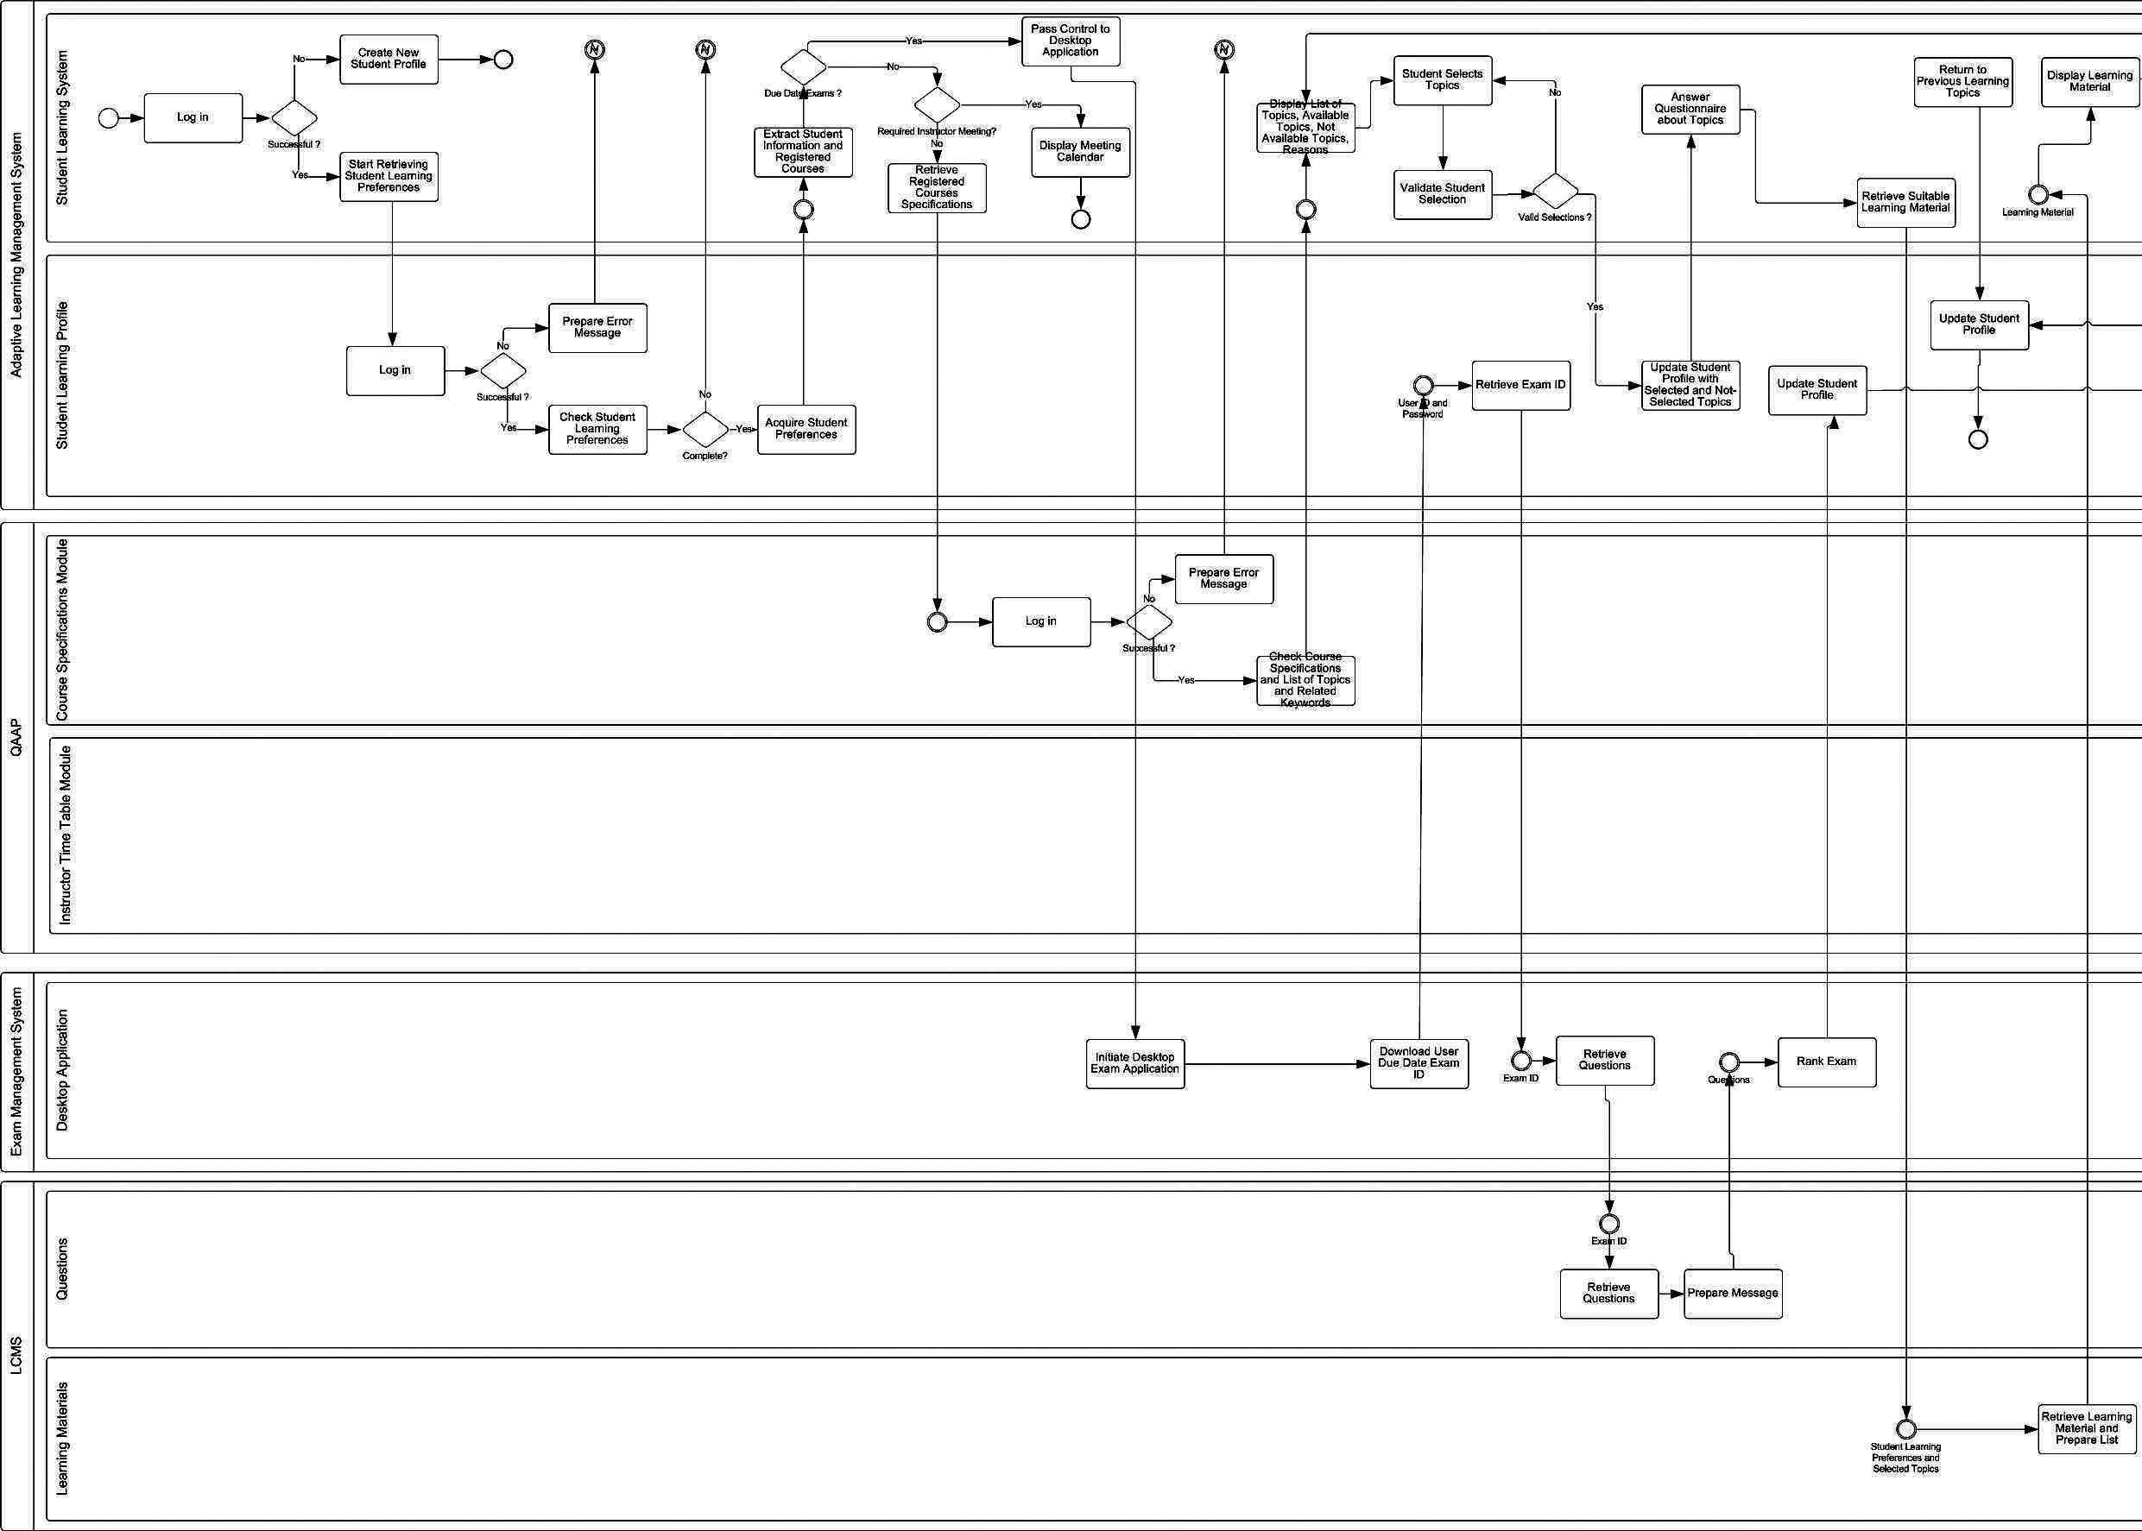
Figure 12(a): Proposed Learning Model
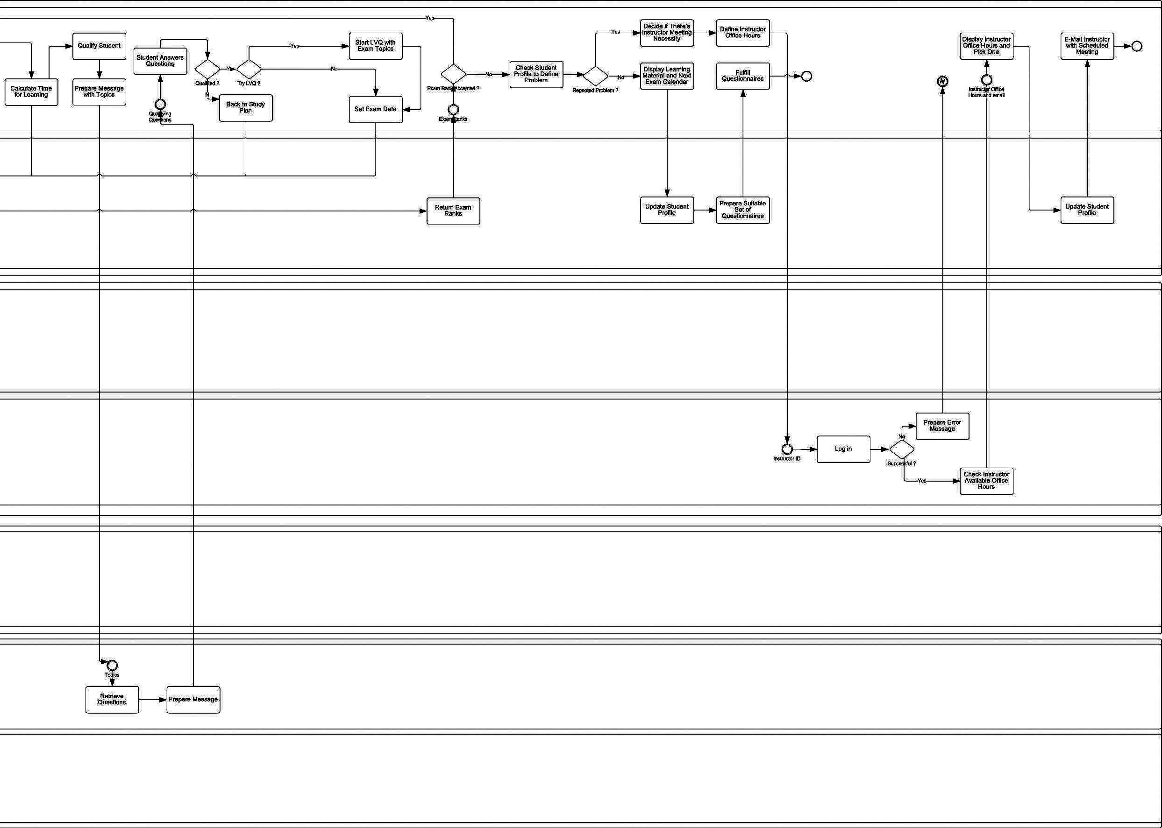
Figure 12(b): Proposed Learning Model (cont.)
Student selects the topics s/he wants to learn. Student learning profile is then updated with selected and not selected topics. Student learning system displays the suitable learning material and a list of recommended learning material and what others have seen learning material list. Student learning system qualifies student to make sure student got the learning objectives of the topic. If the student is not qualified, then s/he is back to the study plan. Student can quit learning at any time and continue learning later from her/his library section. Then student learning systems checks either the topics student has learned forms an exam, so student now becomes eligible for exam. Student can; upon her/his choice goes through Learn Via Questions (LVQ) experiment. LVQ is a sub system that simulates the exam environment by presenting questions with feedback, so student can measure her/his readiness for exam. The main objective of LVQ is helping student define their readiness level, not testing them. If student want to skip LVQ, they get an exam date, and the learning process moves to Student (B).
Student (B) logs in the system and s/he has a due exam, so student learning system attempts to initialize the desktop application. Exam application retrieves questions from LCMS questions repository based on the exam ID submitted from student learning system, ranks exam, and updates student profile with the rank. The next time student logs in; s/he finds her/himself continuing learning new topics.
Student (C) faces troubles with some topics. S/he attended the exam twice but didn’t pass, so the third time she logs in, she attend the exam and she doesn’t (ass, she automatically see the instructors calendar, so she picks the suitable time for meeting. The meeting details with detailed student profile are mailed to the instructor. The next time the student logs in, s/he finds the system paused and the calendar is displayed. Only instructor can solve the situation after meeting the student by reactivating the student account after the proper action is taken and recorded in the study profile. Instructor can illustrate the topic more than once to the student, exam her/him orally or written, or whatever the instructor finds appropriate.
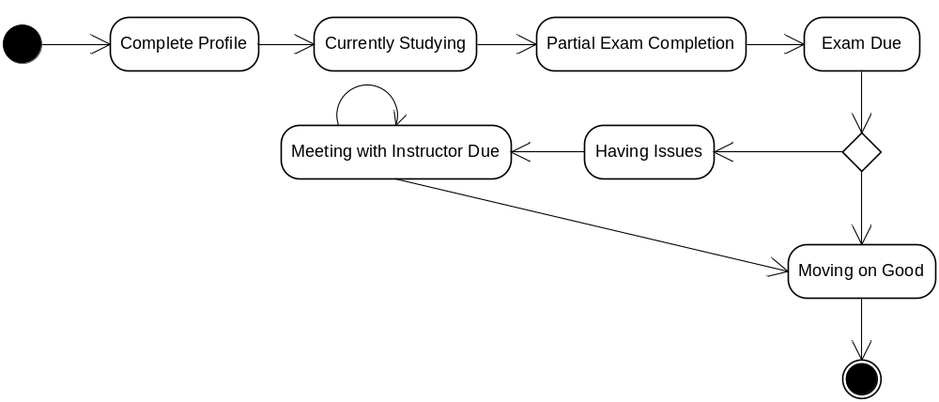
Figure 13: Student State Transition Diagram
  - Adaptive Features in Proposed Model
Four main approaches which can be used to give a historical overview of adaptive e-Learning are Macro Adaptive, Aptitude-Treatment Interaction (ATI), Micro-Adaptive, and Constructivistic-Collaborative approaches. (Felix Modritscher 2004). Here, we present a mapping between the four approaches and our proposed model adaptive features.
    - Macro Adaptive Approach
This approach addresses adaptation of instructions on a macro-level by allowing different alternatives in selecting a few main components such as learning objectives, levels of detail, delivery system, etc. In this approach, instructional alternatives are selected mostly on basis of the student’s learning goals, general abilities, and achievement levels in the curriculum structure. Proposed Model addresses this capability by testing student profile and learning preferences before establishing learning material.

    - Aptitude-Treatment Interaction (ATI) Approach
This approach treats adaptation of instructional strategies to specific student’s characteristics. This strategy proposes different types of instructions or even different media types for different students. One aspect of the ATI approach is the user’s control over the learning process according to the abilities of the students by giving them full or partial control over the style of the instruction or the way through the course. Level of control can be one of three levels: complete independence, partial control within a given task scenario, and fixed tasks with control of pace. Proposed Model addresses this approach by allowing the student to choose among topics to learn (within the constraints of the pre-requisites) that gives them the partial control experience. Also, the proposed model provides the capability to arrange meetings between instructors and students having issues with certain learning topics. Students are given the chance to self study the subjects and attend the exams for 3 times. If this number of times is exceeded without passing the exam, a meeting must be arranged between instructor and student, and a repost submitted by the instructor to the student profile, so student can continue the learning process again in the adaptive way. This sort of blended learning gives strength to the proposed model.

    - Micro-Adaptive Approach
This approach addresses adaptation of instructions on a micro-level by diagnosing the student’s specific learning needs during instruction and providing instructional prescriptions for these needs. Researchers have attempted to establish micro-adaptive instructional models using on-task rather than pre-task measures. Monitoring the user’s behaviour and performance, such as response errors, response latencies, emotional states, etc. can be used for optimizing instructional treatments and sequences on a very refined scale (Christian Gutl et al. 2003). Proposed Model addresses this approach by providing the capability to calculate the required time to study for each learning topic.

    - Constructivistic-Collaborative Approach
An important element of this approach is the usage of collaborative technologies which are considered often on essential component of e-learning. Adaptive system enables learning by focusing on how knowledge is learned and should consider the context, learning activities, cognitive structures of the content, and the time extension. Online forum, wiki, and blog services will be available to students so we enhance them to collaborate, and help each other. Facilities to enable online study groups like chatting applications can be made available. Arguments around the effectiveness of Web 2.0 features in e-Learning are taking place all around.
Table 1 presents a summary of the mapping between proposed adaptive features in the proposed learning model and the four adaptive learning approaches. Besides, proposed model combines both Adaptable and Adaptive capabilities. Adaptability made available by giving students the capability to define and edit their personal preferences, which will affect directly their learning experience.
Table 1: Summary of Proposed Model's Adaptive Features and Adaptive Learning Approaches
Adaptive Feature of the Proposed Model | Adaptive Learning Approach
Adaptation of Instructions on a Macro Level | Macro Adaptive Approach
Allowing Students to chose among topics to learn taking in consideration pre-requisites | Partial Control, Aptitude Treatment Interaction (ATI) Approach
Suspend Account and Arrange Meetings with Instructors based on Learning Situation | Aptitude Treatment Interaction (ATI) Approach
Online Forum, Wiki, Blog, Chatting, Grouping Services | Constructivistic – Collaborative Approach

- Proposed Solution IT Architecture
Proposed solution IT is complex and includes the utilization of different technologies to achieve the required goal. There are already installed and running systems that can’t be changed at once. Though those systems are not old enough but we will refer to them as legacy systems; they are out of scope to us, however proposed solution needs them and their data. SOA utilization has many advantages over other software architecture paradigms in solving integration challenges (A. M. Riad et al. (b), 2009). They are QAAP, Joomla, and Moodle as illustrated in figure 14.
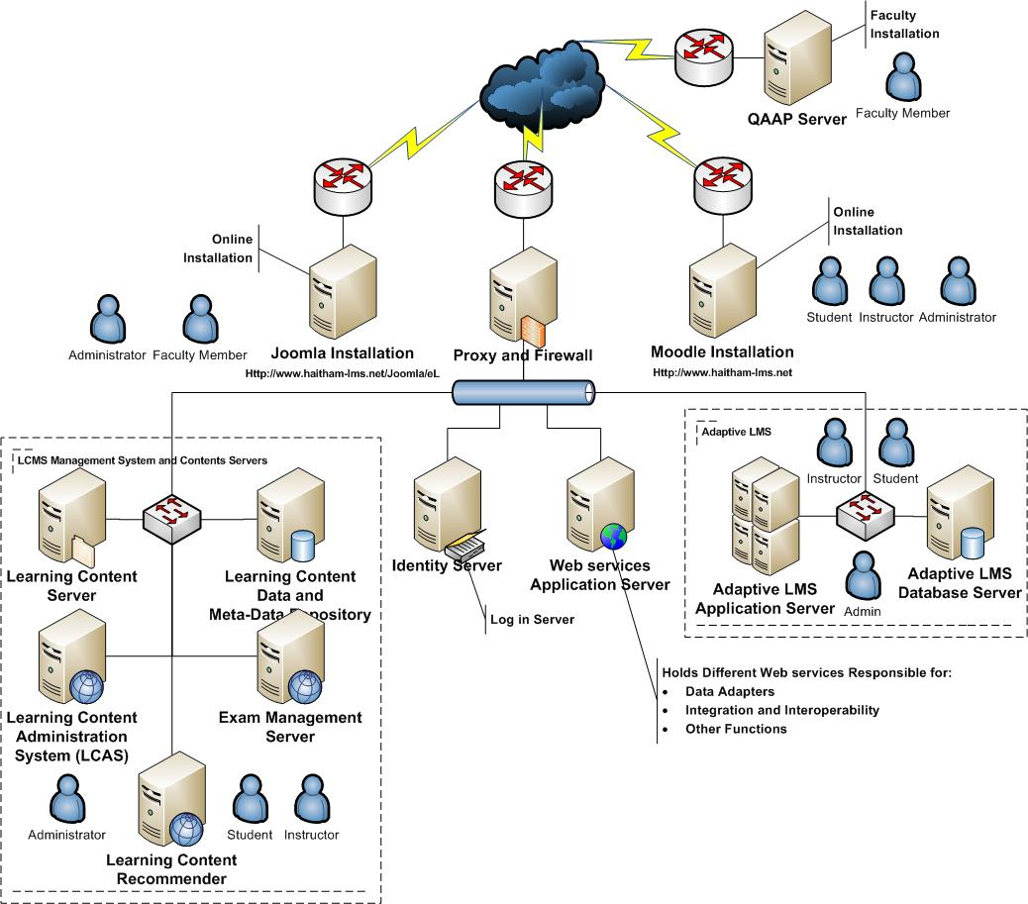
Figure 14: Proposed Solution IT Architecture
QAAP server is managed by faculty members; internally and includes applications that are related to course specifications and instructors. Moodle is an open source LMS that is widely accepted and used over learning institutions to provide online learning facilities and management capabilities. Joomla is an open source Content Management System (CMS) used to manage and publish online contents. So, to implement the posposed learning model, IT modification shall be presented:
- Proxy and Firewall Server: shall be added at the gate between online and external systems, and the proposed Model Server Components
- Identity Server: shall be added to enable single sign-on authentication and authorization capabilities for the whole solution
- Web services Application Server: shall be added to hold Web services responsible mainly for:
  - Data Adapter: accessing data stored at QAAP, Moodle, Joomla
  - Integration and Interoperability: between different servers based on different required functionalities
- Learning Content Management System (LCMS) and Content Servers: Logically, the following servers are required to manage presented functionalities:
  - Learning Content Server: to hold learning materials physical files. Different implementation can include FTP Server.
  - Learning Content Data and Meta Data Repository: to maintain SCORM v. 2.0 Data and Meta Data about learning materials. This data will be used to determine the appropriate learning materials for students.
  - Learning Content Administration System (LCAS): holds the application that enables administrators to manage learning content files, learning content data, and learning content metadata. Different LCAS functionalities are presented in figure 15 presents LCAS use case diagram.
  - Exam Management Server: manages exam process and accesses LCMS questions based on exam IDs.
  - Learning Content Recommender: works on learning contents data, metadata, students learning profiles, students learning history, instructors’ recommendations to recommend learning materials to students.
- Adaptive LMS: responsible for providing adaptive features presented in the proposed model and providing the main interface for students to access the Web application
  - Adaptive LMS Application Server: holds the portal that can be accessed by students
  - Adaptive LMS Database Server: holds student profiles, learning preferences, and learning history.
- Integration of Proposed Model Components Via SOA
Combination of both Business Process Management (BPM) and Service Oriented Architecture (SOA) is proven to achieve numerous advantageous features for systems. Proposed Model presented an adaptive learning process that adaptively change based on student performance. SOA is the utilized architecture in integrating the different components required to support the proposed adaptive learning process. SOA is the architectural design that presents systems as collection of services grouped together to satisfy system requirements. Our proposed model composing services can be categorized in the layers depicted in figure 16.

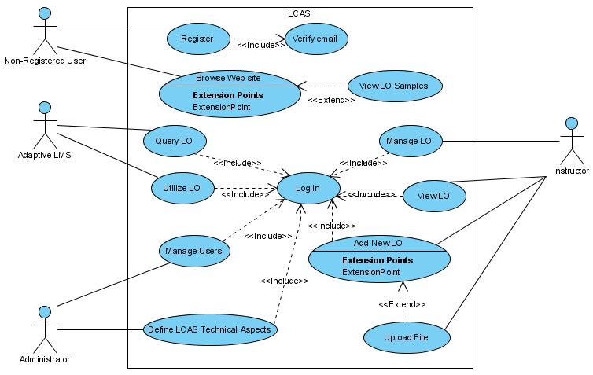
Figure 15: LCAS "Learning Content Administration Server" Use Case Diagram

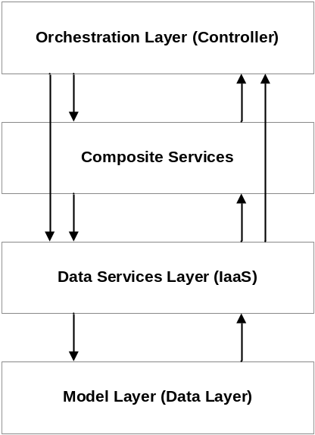
Figure 16: Proposed Model Layered Architecture

Table 2 presents a summary of proposed layer services, mapped with proposed model IT infrastructure diagram to highlight the implementation of the services, and what services actually utilized. Table 2 layers are:
- Orchestration Layer: holds services responsible for maintaining learning process logic and activities. It includes services that utilize both composite services’ layer services, and data services’ layer services.
- Composite Services: are services that holds other services and don’t complete functioning unless all composing services execute successfully; however it is not controlling them
- Data Services Layer (Information as a Service “IaaS”): is the layer that holds services responsible for transforming Metadata into meaningful information to other utilizing information systems, instructors, and students. Figure 17 preseents an E-R Model for Sharable Content Object Reference Model (SCORM) v. 2.0 utilized standard to describe learning content data and metadata. Learning object has mainly five aspects: educational, technical, metadata, copyrights, and lifecycle. General entity in the middle of the diagram is connected to the abovementioned five main entities that represent each of the previous aspects. Data adapters for accessing external system components are presented in this layer. QAAP data adapter, Joomla data adapter, and Moodle data adapter are presented for accessing QAAP, Joomla, and Moodle servers respectively.
- Model Layer (Database): it is rather the database layer that holds data tables. Figure 18 presents the SCORM v. 2.0 database tables for Learning Objects; data and metadata.
Table 2: Summary of Proposed Model Services, Categorized by Architecture Layers, and Mapped to
IT Infrastructure
Design Layer | Service Name | Parent System | NW Diagram Server | Utilized Services
Orchestration Layer (Controller) | O1: Search for Learning Object | Adaptive LMS | Adaptive LMS AS | C1,C2
Orchestration Layer (Controller) | O2: Learn New Topics | Adaptive LMS | Adaptive LMS AS | D2, D3, D4, D5
Orchestration Layer (Controller) | O3: LVQ “Learn Via Questions” | LVQ
Orchestration Layer (Controller) | O4: Meetings with Instructor | Adaptive LMS |  | D5,D10
Composite Services | C1: Adaptive Search | LCMS | Learning Content Recommender | D1,D5
Composite Services | C2: Intelligent Search | LCMS | Learning Content Recommender | D1
Data Services Layer (IaaS) | D1: Learning Objects Manager | LCMS | LCAS | DB1
Data Services Layer (IaaS) | D2: Lessons Manager | Adaptive LMS | Adaptive LMS AS | DB2
Data Services Layer (IaaS) | D3: Topics Manager | Adaptive LMS | Adaptive LMS AS | DB2
Data Services Layer (IaaS) | D4: Course Manager | Adaptive LMS | Adaptive LMS AS | DB2
Data Services Layer (IaaS) | D5: Student Profile Manager | Adaptive LMS | Adaptive LMS DB Server | DB3
Data Services Layer (IaaS) | D6: Questions Manager | LCMS | Exams Management Server | DB4
Data Services Layer (IaaS) | D7: Exams Manager | LCMS | Exams Management Server | DB4
Data Services Layer (IaaS) | D8: Questionnaires Manager | Adaptive LMS | Adaptive LMS AS | DB3
Data Services Layer (IaaS) | D9: Course Module Adapter | QAAP | Web services Application Server | --
Data Services Layer (IaaS) | D10: Instructor Data Adapter | QAAP | Web services Application Server | --
Data Services Layer (IaaS) | D11: Moodle Data Adapter | Moodle | Web services Application Server | --
Data Services Layer (IaaS) | D12: Joomla Data Adapter | Joomla | Web services Application Server | --
Model Layer (Databases) | DB1: Learning Objects (Data and Meta Data) | LCMS | Learning Content Data and Meta Data Repository | --
Model Layer (Databases) | DB2: Lessons, Topics, and Courses | Adaptive LMS | Adaptive LMS DB Server | --
Model Layer (Databases) | DB3: Student Profiles and Questionnaires | Adaptive LMS | Adaptive LMS DB Server | --
Model Layer (Databases) | DB4: Questions and Exams | LCMS | Exams Management Server | --
- SCORM and Proposed Model
Figure 17 and 18 presented an overview of SCROM v.2.0 based E-R Diagram and database tables that is implemented in the proposed model. SCORM is the utilized standard to store metadata about Learning Objects (LOs). LO is the basic building block of a learning resource, it is the electronic representation of media, such as text, images, sound, assessment objects or any other piece of data that can be rendered by a Web client and presented to a learner. LO’s meta-data can be grouped into four main categories from authors’ point of view: General, Educational, and Technical.
- General: Category groups the general information that describes the resource as a whole. Stores data about keywords, description, structure, and aggregation levels.
- Technical: The Technical category describes all of the technical characteristics and requirements of the SCORM Content Model Component. Technical category focuses on format, size, and installation remarks of the LO. Besides, the requirements for running the LO.
- Educational: The Educational category describes the key educational or pedagogic characteristics of the LO. This category allows for the description of the educational characteristics and is typically used by teachers, managers, authors and learners. Focuses on data like interactivity type, interactivity level, typical age range of the LO, and context.
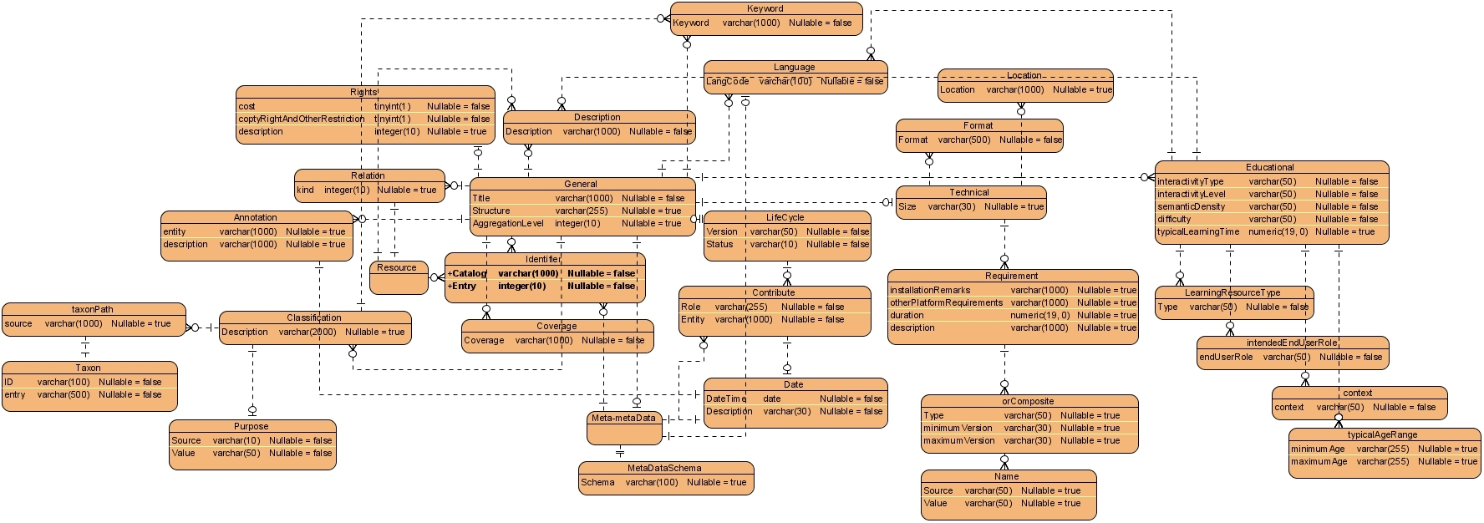
Figure 17: SCORM v. 2.0 E-R Model
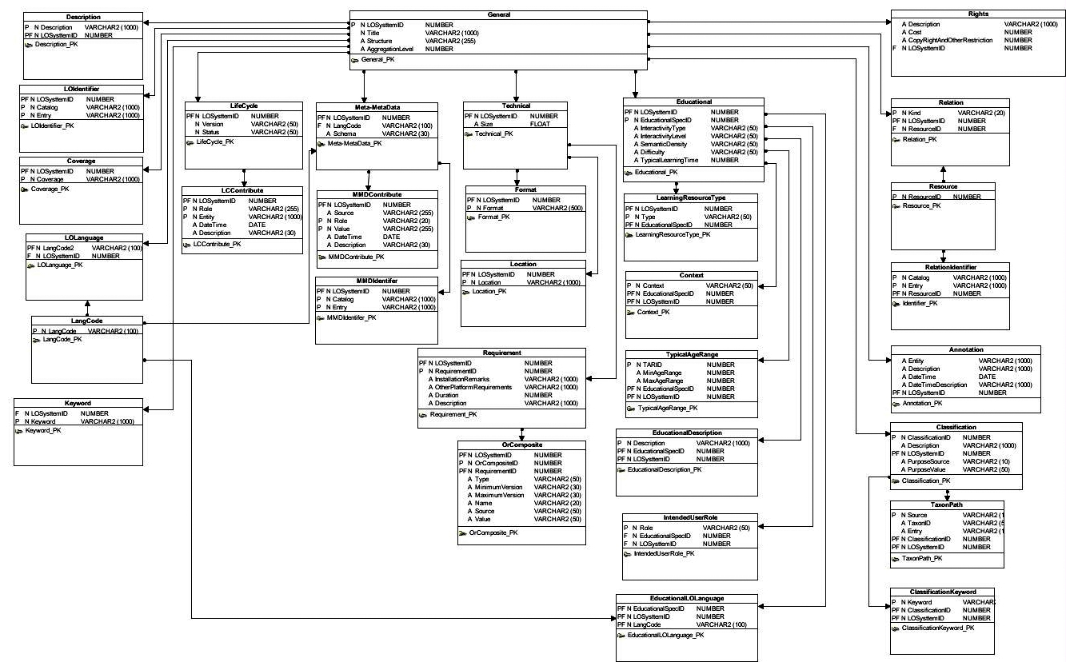
Figure 18: SCORM v. 2.0 Database Tables
- LOs Recommender as a Service
Recommender system in an e-Learning context is a software agent that tries to “intelligently” recommend actions to a learner based on the actions of previous learners. This recommendation could be an online activity such as doing an exercise, reading posted messages on a conferencing system, or running an on-line simulation, or could be simply a web resource (Osmar R. Zaiane, 2002).
Proposed model presents LOs Recommender as a Service that makes use of different technologies and techniques presented by A. M. Riad et al. (A. M. Riad et al. (c)) in utilizing Co-Occurrence Matrix based recommender to present suitable learning materials to students. Modifications to previous recommender were required to fit the new recommendation scenario. LOs Recommender as a Service relies heavily on LO’s SCORM Meta Data presented in section 6. Figure 19 presents an overview of LOs Recommender as a Service recommendation process. Student; the main initiative of the learning process asks for suitable LOs that fits the learning objectives of the course topics. S/he finally gets three different lists of LOs: Ranked LOs list, list of LOs from Google Scholar, and an Instructor Recommended List.
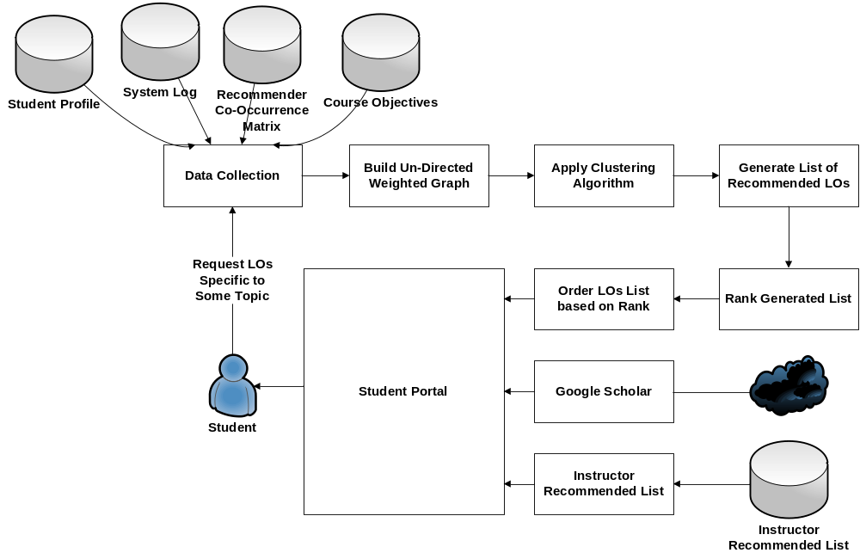
Figure19: LO's Recommender as a Service Process
Student request can be identified either implicitly through LOs Recommender as a Service observation of students’ navigation through learning topics or explicitly through an ordinary search using Proposed Adaptive System Web site’s interface. On receiving a new request, LOs Recommender as a Service generates a set of recommendations; a list of ranked suggested LOs to view based on content similarity with student request side by side with results from Google Scholar.
At each request, LOs Recommender as a Service identifies the requested LO, Session ID, Student ID, and Referrer LO; that is the LO the student was viewing before the requested one. Based on students’ access behaviour, Recommender as a Service updates the underlying Co-Occurrence Matrix as depicted in figure 20. Co-Occurrence Matrix is the mind of the Proposed LOs Recommender as a Service and it is reactive because it reflexes students’ access to LOs as it updates weight between LOs based on students’ navigation model between LOs. Co-Occurrence Matrix is a Matrix
M = N * N
Where
N = No. of LOs in LCMS
Each element in the Co-Occurrence Matrix presents a Weight W(u,v). The equation used to update Co-Occurrence Matrix values is
W(u,v) = N(u,v) / Max (Nu,Nv)
Where
W(u,v) = Weight of adjacent LOs (u,v)
N(u,v) = Number of Students’ Sessions in which both LO(u) and LO(v) are visited
N(u) = Number of Sessions in which LO(u) is visited
N(v) = Number of Sessions in which LO(v) is visited

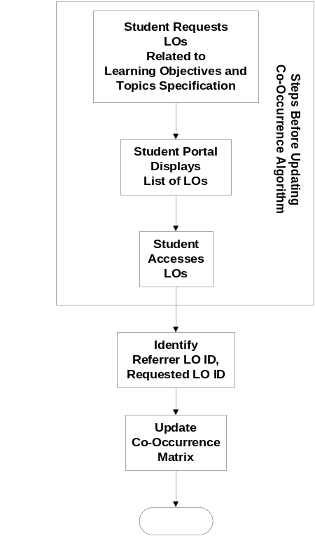
Figure 20: Update Co-Occurrence Matrix Steps

LOs Recommender as a Service relies on a Co-Occurrence Matrix that is stored in the database between different LOs. Building this Co-Occurrence Matrix is a student reactive process because it is mainly based on student navigation model between LOs. LOs Recommender as a Service gathers data required to recommend LOs to students from different data sources, and then builds Un-Directed Weighted Graph between the appropriate LOs based on the stored Co-Occurrence Matrix. The Clustering Algorithm is applied to this Un-Directed Weighted Graph to define different clusters and Generate the Recommended List of LOs. This list is then ranked based on the Ranking Algorithm and returned to the user.
  - Building Un-Directed Weighted Graph
The Un-Directed Weighted Graph is built programmatically based on the equation:
G = (V, E)
Where
V = Set of Vertices; that contains LOs Identifiers
E = Set of Weighted Edges between Vertices
An example of the Un-Directed Weighted Graph between LOs is the one presented in figure 21. Un-Directed Weighted Graph doesn’t highlight the order of viewing LOs; because this ordering will complicate the Clustering process.
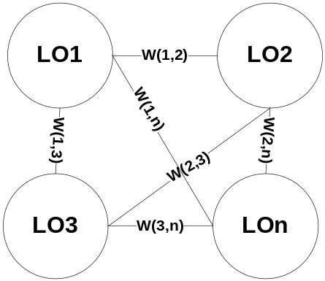
Figure 21: Example of Un-Directed Weighted Graph between LOs
  - Applying Clustering Algorithm
LOs Recommender as a Service finds clusters based on Usage Data Analysis by Partitioning the built Un-Directed Graph to its Connected Components, assigning each component; that would be an LO into a different cluster based on a threshold value that is used to exclude poor correlated edges. The List of Recommended LOs contains LOs that coexist within the same cluster of the LOs of the requested learning topics. Proposed LOs Recommender as a Service utilized clustering algorithm is Depth First Search (DFS). DFS is an algorithm for traversing or searching a tree, tree structure, or graph, and it is used to find graph’s connected components. Threshold value shall be used to eliminate poor correlated edges. A start value of 0.4 is used in the beginning and it is a matter of change for later uses based on LOs Recommender performance.

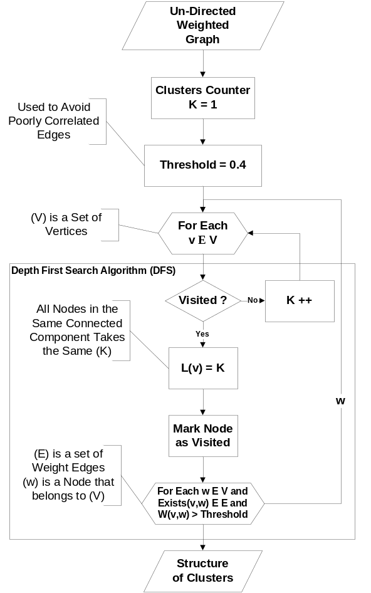
Figure 21: Flow Chart of Implemented Depth First Search Algorithm
  - Applying Ranking Algorithm
Proposed Recommender as a Service uses a Content based Ranking Algorithm for ranking LOs; that is Term Frequency – Inverse Document Frequency (TF – IDF). TF – IDF is calculated as follows:
- Calculate Term Frequency (TF): TF is the measure of how often a term_{i} is found in a particular LO_{j}. Each term in the input string is compared with each LO’s Meta-Data and Content if applicable.
TF_{i,j} = Frequency of Term_{i} in LO_{j} / No. of Words in LO_{j}
- Calculate Inverse Document Frequency (IDF): The number of LOs in which the term occurs divides the toptal number of LOs in the database; resulting in R. The Log of R gives the IDF. IDF is calculated based on the formula
IDF_{i,j} = Log (No_d / No_LOs_Containing Term_{i})
Where
No_d = Total No. of Retrieved LOs
No_LOs_Containing Term = No. of Relative LOs that contain Term_{i}
- Calculate the Weight of Term_{i} in Each LO: The weight of the Term_{i} is calculated indicating the importance of the query term in each document. The higher the weight of a term in a document, the more important is that document.
Weight_{i,j} = TF_{i,j} * IDF_{i,j}
  - Google Scholar
Google Scholar is a freely accessible Web search engine that indexes the full set of scholarly literature across any array of publishing formats and disciplines. Google Scholar is available online at http://scholar.google.com Released in beta in November 2004; the Google Scholar index includes most peer-reviewed online journals of the world’s largest scientific publishers. In terms of features, Google Scholar allows users to search for digital or physical copies of articles, whether they are online or in libraries. Through its “Cited By” feature, Google Scholar provides access to abstracts of articles that have cited the article being viewed. Through its “Related To” features, Google Scholar presents a list of closely related articles ranked primarily by how similar these articles are to the original result and how much relevance of each paper.
- Conclusion
There is a clear need for adaptive and intelligent features in current e-Learning systems to provide students with personalized learning environments they need. One of the e-Learning challenges that became clear after surveying 57 students in year 2008 was the absence of current e-Learning systems to adaptively and intelligently touch students’ capabilities. This paper presented an adaptive learning model that blends instructor lead education with e-Learning capabilities. Learning Objects (LOs) Recommender as a Service that is important to support the proposed Adaptive Learning Model is presented. LOs Recommender as a Service utilizes LOs Meta-Data and Student Preferences based on Students’ Navigation Model between different LOs. Presenting adaptive and intelligent features as services with standard interfaces will allow different e-Learning systems to adopt them, so they will be reusable and newly introduced information systems will not have to redo the work again. Besides, wrapping adaptive and intelligent features with standard interfaces will present a separation of interests that help adaptive and intelligent features’ researchers and developers to focus more on their target and transfer the responsibility of utilizing those features in different information systems to information systems specialists. Today’s e-Learning information systems’ architects can make use of SOA in integrating major e-Learning components together, side by side with adaptive and intelligent features. Future work includes utilizing different algorithms and intelligent techniques in providing proposed system functionalities. There is a growing attention to the importance of Semantic Web in the near future to introduce Web 3.0. Semantic Web challenges of the proposed system are Semantic Web Calendar, and Semantic Web Search Engines.
References
Alfred Bork, Carole A. Bagley, Xiwen Zhang, “Technology and Learning: A proposal for Adaptive Learning Tutorial”, Michael Allen's 2008 e-Learning Annual, J-B Pfeiffer Annual Looseleaf Vol1, 2008.

A. M. Riad, and H. A. El-Ghareeb (a), “A Service Oriented Architecture to Integrate Mobile Assessment in Learning Management Systems”, Turkish Online Journal of Distance Education - TOJDE April 2008 ISSN 1302-6488 Volume: 9 Number: 2 Article 12.

A. M. Riad, Hamdy K. El-Minir, Haitham A. El-Ghareeb (a), “Review of e-Learning Systems Convergence from Traditional Systems to Services based Adaptive and Intelligent Systems”, Journal of Convergence Information Technology, Vol. 4, No. 2, June 2009
A. M. Riad, Hazem M. El-Bakry, Haitham A. El-Ghareeb (b), “Mapping Different Software Architecture Paradigms to Different Integration Techniques: Highlighting Driving and Restraining Forces for Each Paradigm”, Journal of Convergence Information Technology, Vol. 4, No. 2, June 2009
A. M. Riad, H. K. Elminir and S. F. Sabbeh (c), "Recommender System for E-Research ", Mansoura Engineering Journal “MEJ”, Vol. 33, No. 1, March 2008.

Charles D. Dziuban, Joel L. Hartman, Patsy D. Moskal, “Blended Learning”, Vol. 2004, Issue 7, Educase Connect, 2004

Christian Gutl, Victor Manuel Barrios, Felix Modritscher, “Adaptation in E-Learning Environments through the Service-Based Framework and its Application for AdeLE”, IDC: US Corporate and Government eLearning Forecase, 2003

D. Randy Garrison, and Heather Kanuka, “Blended learning: Uncovering its transformative potential in higher education”, The Internet and Higher Education, Volume 7, Issue 2, 2nd Quarter 2004, pp. 95-105.

Felix Modritscher , Victor Manuel Garcia-Barrios , Christian Gütl, "The Past, the Present, and the Future of adaptive E-Learning", Proceedings of the International Conference on Interactive Computer Aided Learning (ICL2004), 2004

James Ong, Sowmya Ramachandram, “Intelligent Tutoring Systems: Using AI to improve Training Performance and ROI”, Stottler Henke Associates Inc., 2003

Michael Graham Moore, “Handbook of Distance Education”, Lawrence Erlbaum Associates, 2003

Osmar R. Zaiane, “Building a Recommender Agent for e-Learning Systems”, Proceedings of the International Conference on Computers in Education (ICCE’02), IEEE 2002

Sandy Britain, Oleg Liber, “A Framework for Pedagogical Evaluation of Virtual Learning Environments”, JTAP - JISC Technology Application Programme, University of Wales - Bangor, 1999

Willam Horton, Catherine Horton, “E-Learning Tools and Technologies”, Wiley Publishing Inc., 2003

Zongmin Ma, "Web-Based Intelligent E-Learning: Technologies and Applications", Information Science Publishing, 2006

